A000-Afr-D R Congo-Songye-Kifweve figure-Kaolin Painted Face-early 20th c

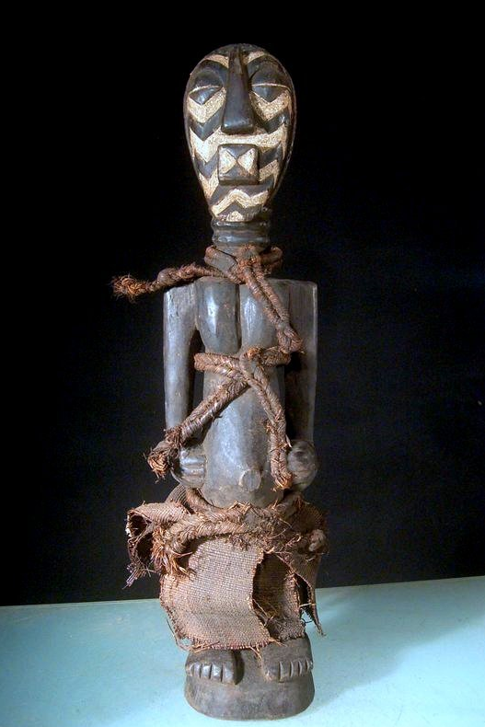

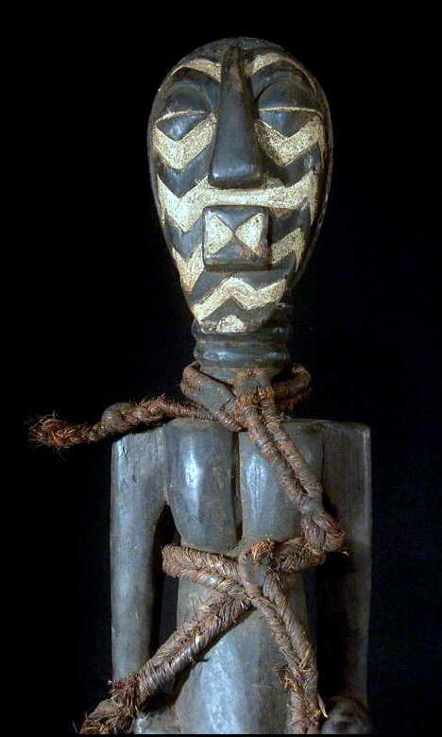 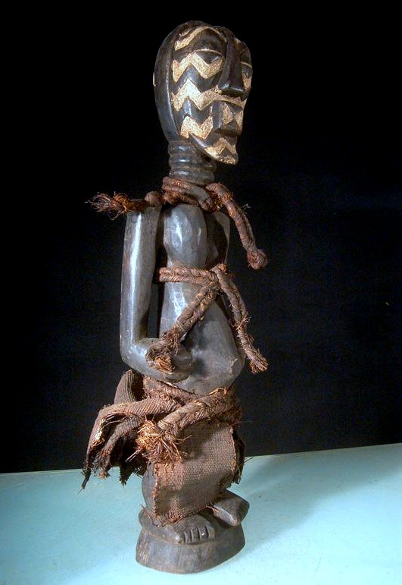 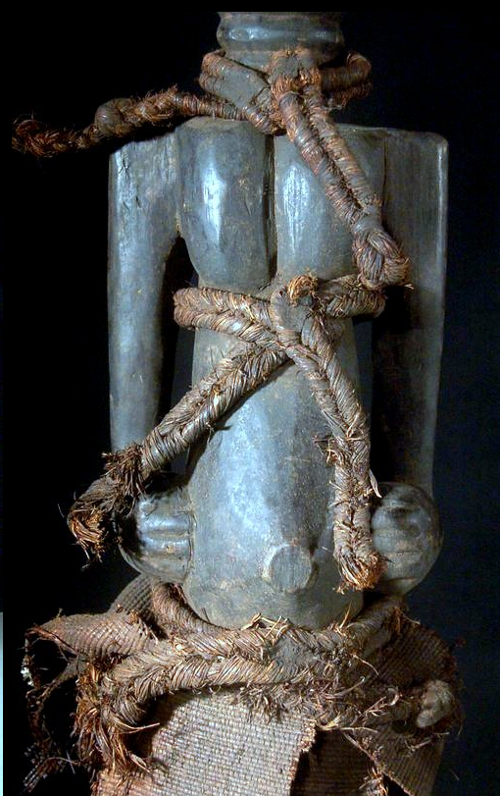 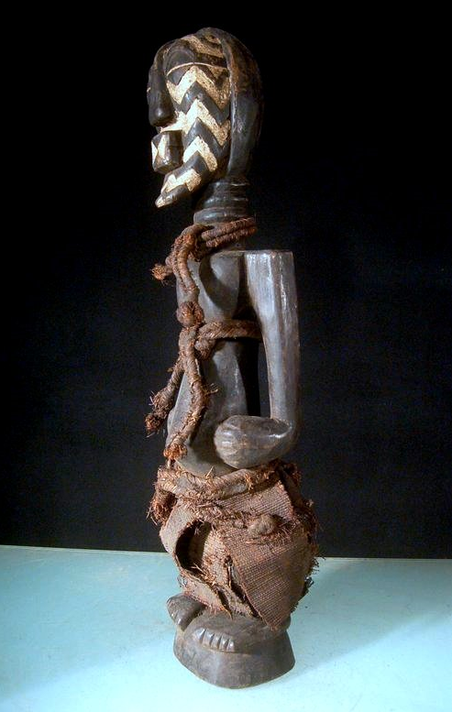 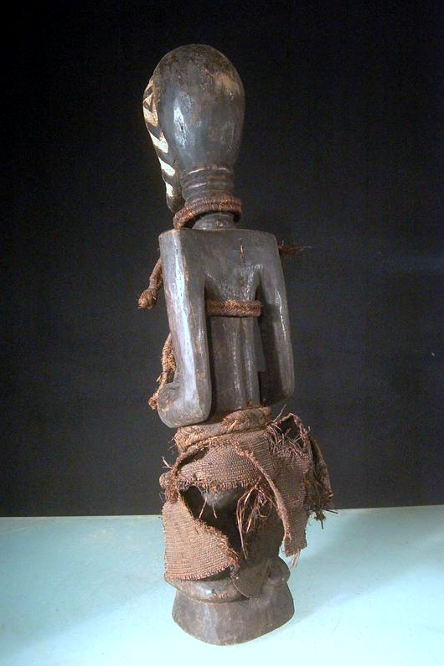

Figs. 1-6. Afr-D R Congo-Songye-Kifweve figure-Kaolin Painted Face-early 20th c

Case No.: 6

**Accession No.**

**Formal Label:** Afr-D R Congo-Songye-Kifweve figure-Kaolin Painted Face-early 20th c

**Display Description:**

Large tribal used African Kifwebe figure from the Songye, Congo.

Hand carved from a single piece of wood, with color pigments and cut in linear ornaments.

Among the Songye the kifwebe society functions as the organ of control in the service of the ruling elite. It helps the authorities maintain their economic and political power. The kifwebe figures count as some of this society’s most powerful collaborators. It is said of these figures that their place is beyond the normal order of the universe. The kifwebe figure embodied supernatural forces and formerly functioned as agents of the ruling elite. The distinctive head in the center of this magnificent figure is modeled after the kifwebe mask form of the eastern Songye.

**Accession Number:**

**LC Classification:**

**Date or Time Horizon:**

**Geographical Area:**

**Map:**

**GPS coordinates:**

**Cultural Affiliation:**

**Media: wood, kaolin**

**Dimensions:** H 67 cm

**Weight:**

**Condition: original**

**Provenance:** from the Songye, Congo

**Discussion:**

**References:**